Iphone and iPhone iOS update
Accessibility Shortcut
Configure and then triple-click the Side Button to toggle accessibility features on or off.
Go to Settings > Accessibility > Accessibility Shortcut, then select the features you want.
TRIPLE-CLICK THE SIDE BUTTON FOR:
- AssistiveTouch
- Background Sounds
- Classic Invert
- Color Filters
- Control Nearby Devices
- Conversation Boost
- Full Keyboard Access
- Dim Flashing Lights
- Eye Tracking
- Hover Typing
- Live Recognition
- Increase Contrast
- Left/Right Balance
- Live Captions
- Live Speech
- Magnifier
- Music Haptics
- Reduce Motion
- Reduce Transparency
- Reduce White Point
- Smart Invert
- Speak Screen
- Switch Control
- Vehicle Motion Cues
- Voice Control
- VoiceOver
- Zoom
AssistiveTouch

Go to Settings > Accessibility > Touch > AssistiveTouch, then turn on AssistiveTouch
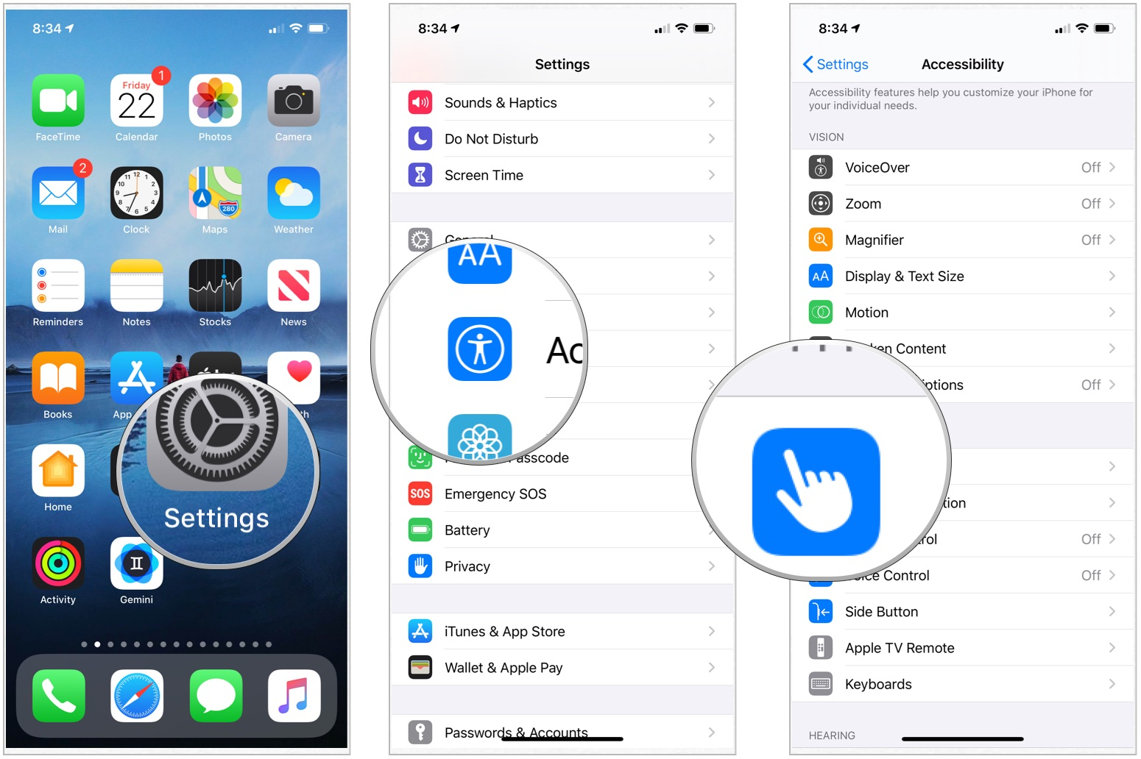
When you turn on AssistiveTouch, you see a button appear onscreen. You can drag the button to any edge of the screen, where it stays until you move it again.
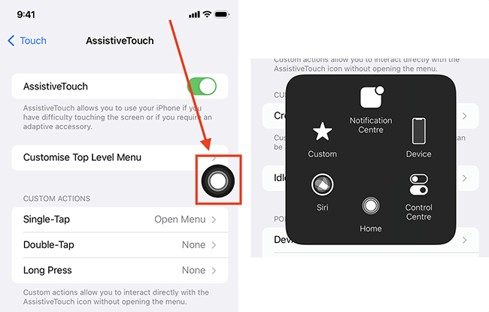
Live Captions
Settings > Accessibility > Live Captions

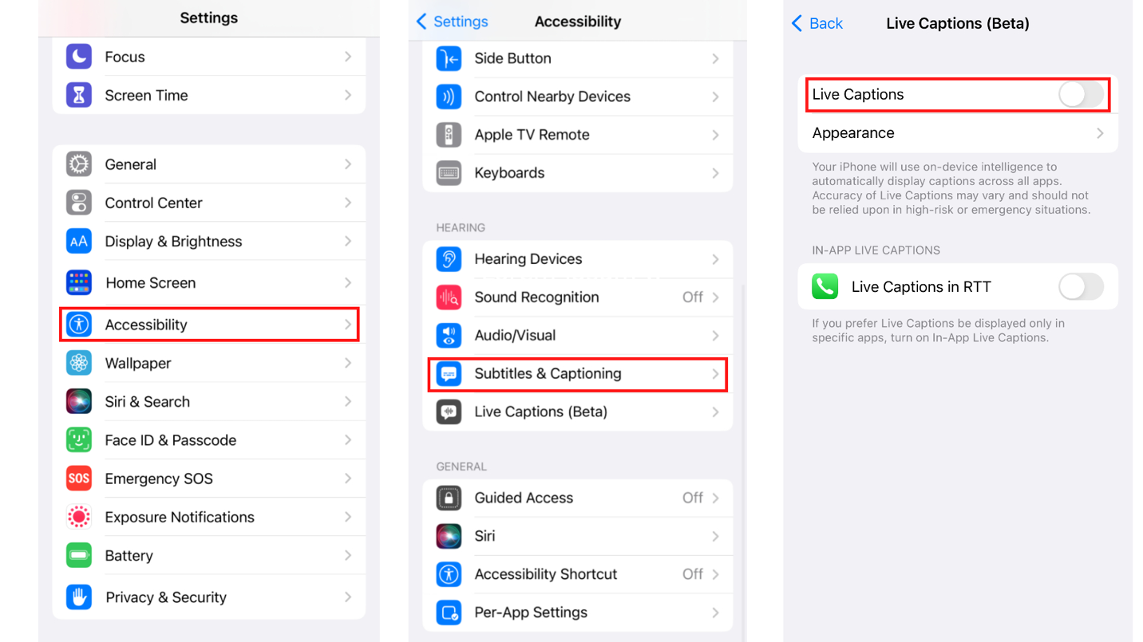

Use Live Captions
With Live Captions turned on, iPhone automatically transcribes the spoken audio in apps—or from dialogue around you. You can do any of the following:
- Transcribe an in-person conversation: Tap Live Captions, then tap Microphone.
- Transcribe iPhone audio: Tap Live Captions, then tap iPhone Audio.
- Pause the transcription: Tap Live Captions, then tap Pause Listening.
- Move the Live Captions window: Drag the Live Captions window to reposition it on the screen.
- Hide the Live Captions window: The Live Captions window is automatically hidden when no audio is detected. If the window is showing, swipe left or right on the window to hide it. To restore the window, tap .
- Make the transcription window full-screen: Tap . To restore the window to the smaller size, tap .

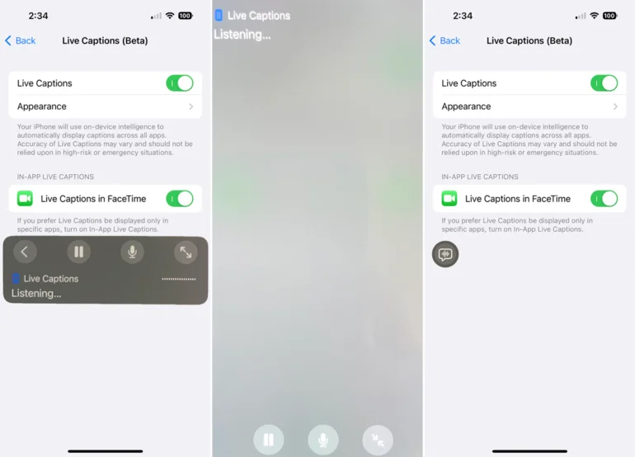

Triple-click the side button to switch it on and off

Android: Live Captions

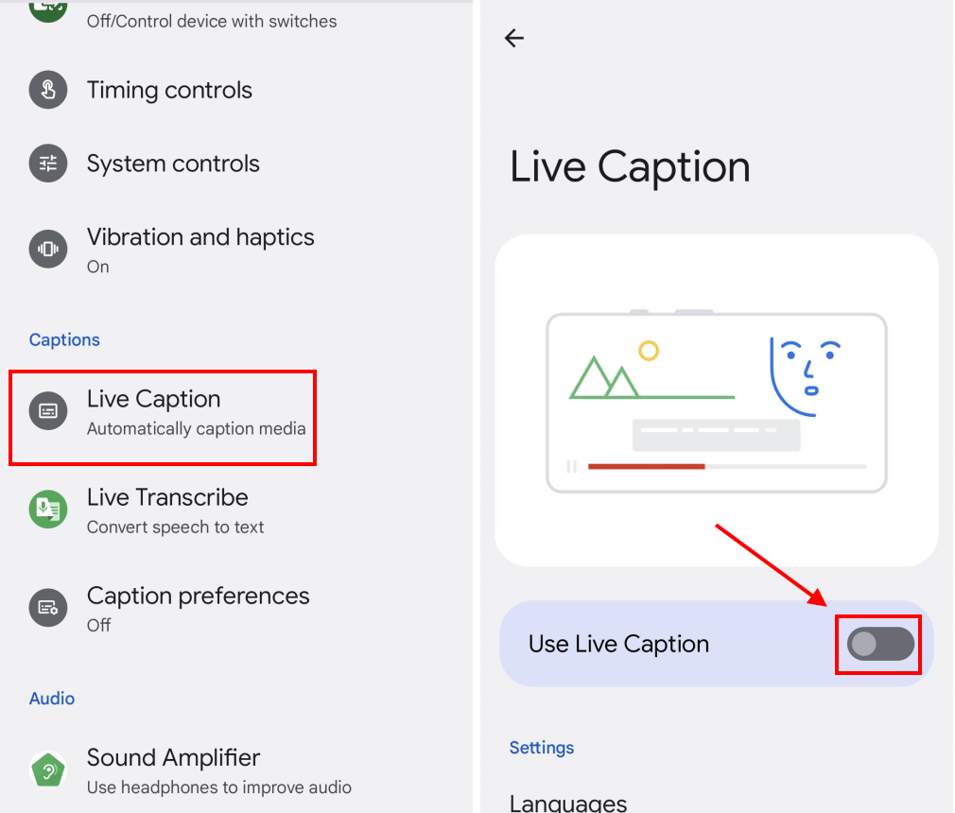
How to turn on
*Go to Settings, then Accessibility, then Live Caption, and turn on Use live captions
How to customize
*Go to Settings, then Accessibility, then Live Caption, and then tap Appearance
How to turn on and off
*Open the device's volume controls
How to change settings
*Go to Settings, then Accessibility, then Live Caption, and then you can:
*Hide or show profanity
*Hide or show sound labels, such as laughter and applause
*Hide or show the Live Caption icon in volume control
*Turn call captioning on or off
