**Participants with Aphasia Invited:**

**Aphasia Therapy Study**

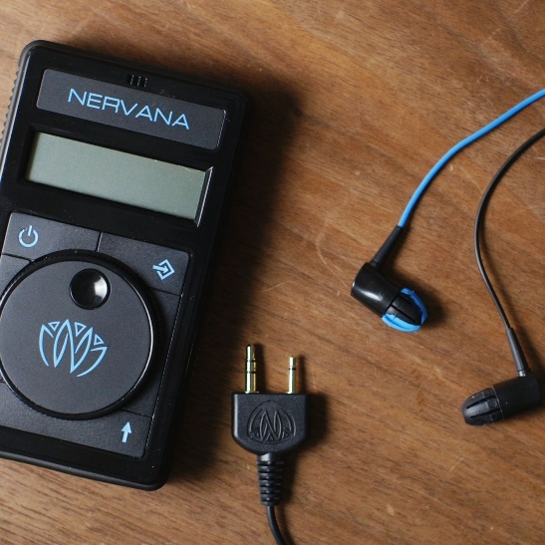

Is **Speech Therapy for Aphasia** more effective with **transcutaneous Vagus Nerve Stimulation (tVNS)**?

To Participate, you must:

* Have aphasia due to stroke
* Be at least 6 months since stroke
* Be age 25-90
* Speak primarily English
* Have no seizure or major cardiac history

For your participation:

* 1 semester of free speech therapy focused on naming (2x/week, 50min sessions, 11-13 weeks)

Involves:

* Pre-semester, midway and semester-end testing for cognition and language
* Wearing the tVNS earbud for a few minutes each session
* Free speech therapy focused on naming

For more information: hesp.umd.edu/clinic/tvns

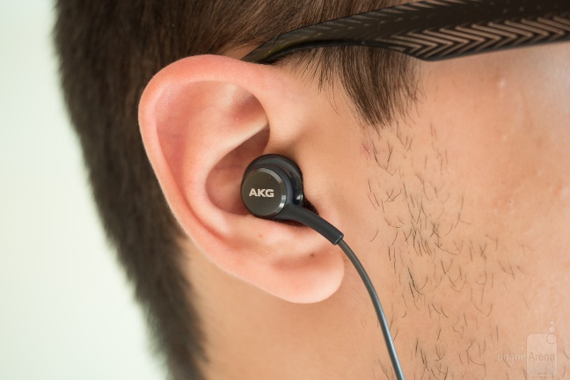





**University of Maryland**

**Hearing and Speech Clinic**

**0110 LeFrak Hall**

**College Park, MD, 20742**

**www.hesp.umd.edu**

**Rochelle Newman**

**Polly O’Rourke**

**Kristin Slawson**

**301-405-8083**

[**kslawson@umd.edu**](mailto:kslawson@umd.edu)