ChatGPT: May 13 2025, the technology NAA asked questions today.
- How to SEND CHATGPT a PICTURE:
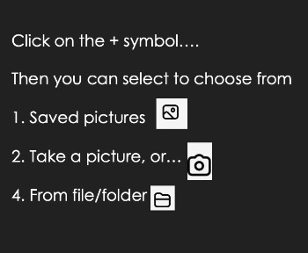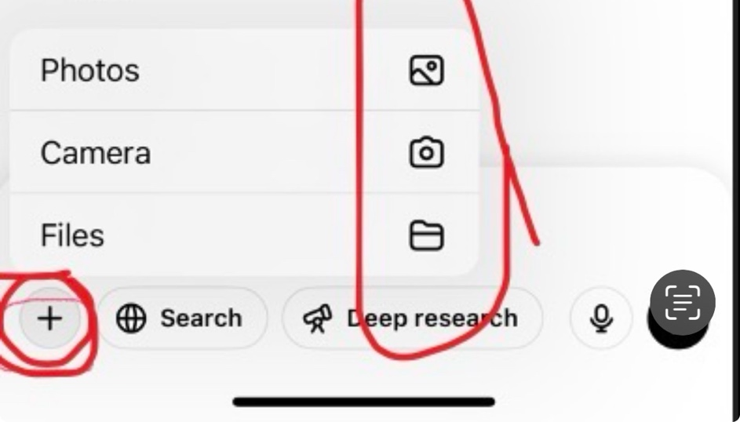

- Saved Content
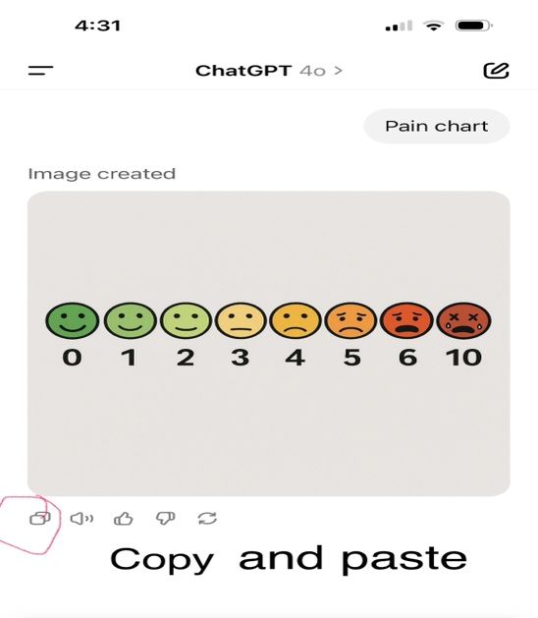
Tips for Organizing or Saving
• You can copy and paste helpful things I say into a Word doc, Notes app, or email.
- How to do grammar?
If you’re working on grammar, I can help by:
•Fixing sentences (example: you write it, and I show the corrected version).
•Giving fill-in-the-blank or sentence-building practice.
•Helping with past tense, plurals, pronouns, etc.

Example:
You type:

She walk to store yesterday.
I help:
She walked to the store yesterday.

- Phone/iPad (Voice Mode)

- Computer: ChatGPT

No Voice Mode in Web ChatGPT (Yet)
•The ChatGPT website (on computer) doesn’t read out loud unless you use another tool.
•That’s why it works on your phone (with voice mode), but not on your computer.

How to Make the Computer Talk Anyway:

Option A: Use “Text-to-Speech” on Your Computer

This makes the computer read what’s on the screen out loud.

On Windows:
•Select the text
•Press Windows + Ctrl + Enter (Narrator)
•Or turn on Narrator in Settings → Accessibility → Narrator

On Mac:
•Highlight the sentence
•Press Option + Esc
•Or go to System Settings → Accessibility → Spoken Content → “Speak Selection”

Option B: Use a Browser Extension

You can install free tools like:
•Read Aloud (Chrome/Edge/Firefox)
•It will read the ChatGPT response out loud.

