**Live Captions: iPhone**

 Settings > Accessibility > Live Captions

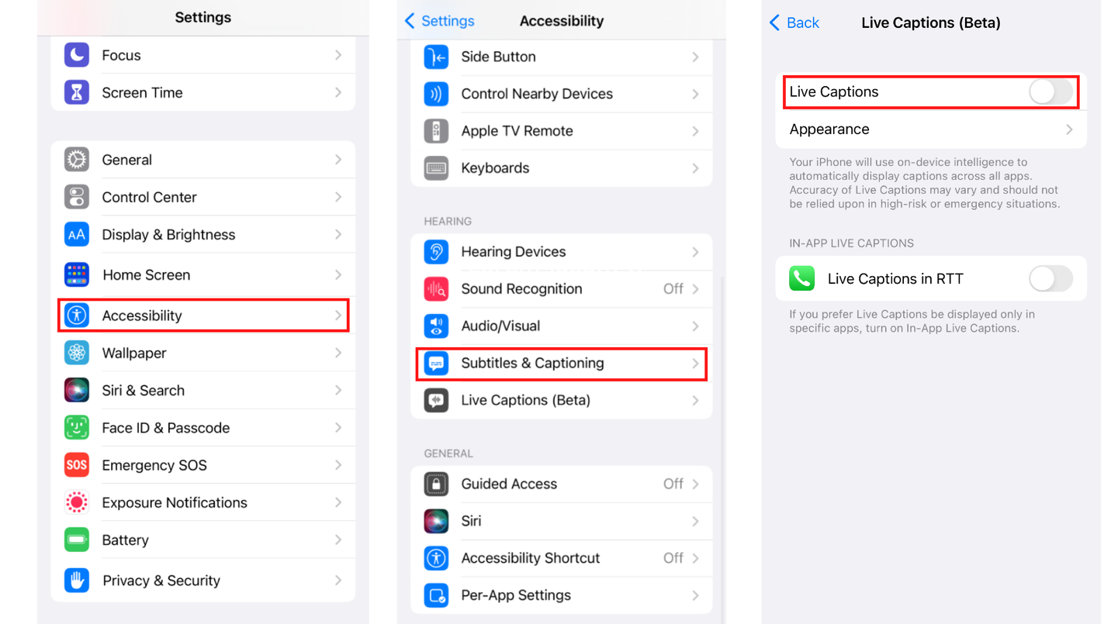

Use Live Captions

With Live Captions turned on, iPhone automatically transcribes the spoken audio in apps—or from dialogue around you. You can do any of the following:

* *Transcribe an in-person conversation:* Tap Live Captions, then tap Microphone.
* *Transcribe iPhone audio:* Tap Live Captions, then tap iPhone Audio.
* *Pause the transcription:* Tap Live Captions, then tap Pause Listening.
* *Move the Live Captions window:* Drag the Live Captions window to reposition it on the screen.
* *Hide the Live Captions window:* The Live Captions window is automatically hidden when no audio is detected. If the window is showing, swipe left or right on the window to hide it. To restore the window, tap the Live Captions Collapsed button.
* *Make the transcription window full-screen:* Tap the Maximize button. To restore the window to the smaller size, tap the Minimize button.

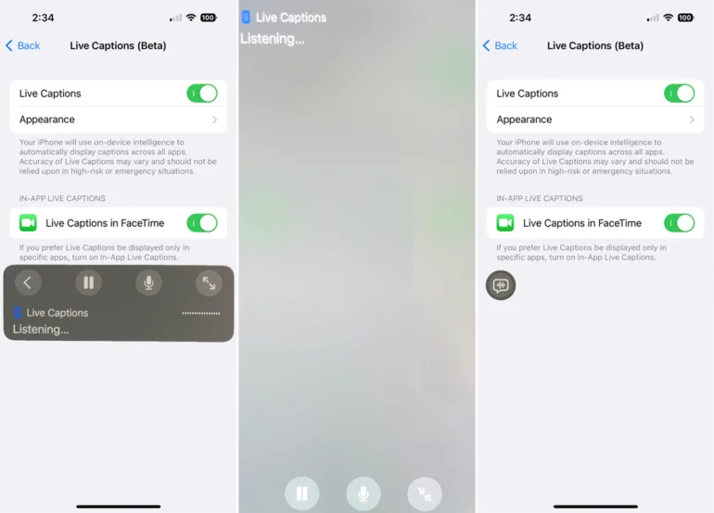

How to customize Live Captions

* Tap Appearance to change the text size, color, and more
* Optionally, censor profanity or show sound effects like laughter
* Disable the Live Caption shortcut in the volume menu

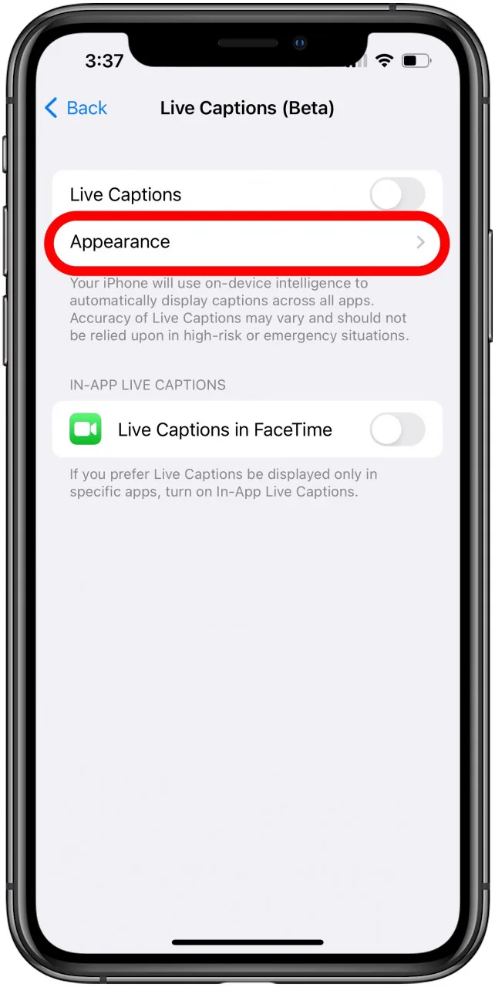

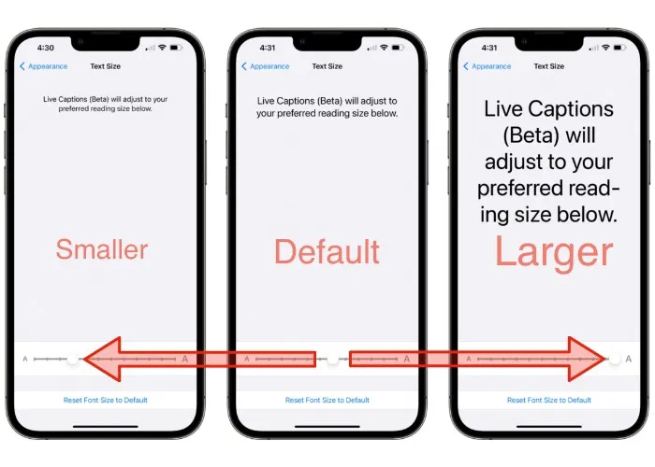

**Go to Settings > Accessibility > Accessibility Shortcut, then select the features you want.**

**TRIPLE-CLICK THE SIDE BUTTON FOR:**

Triple-click the side button to switch it on and off

**Android: Live Captions**

**How to turn on**

*Go to Settings, then Accessibility, then Live Caption, and turn on Use live captions

**How to customize**

*Go to Settings, then Accessibility, then Live Caption, and then tap Appearance

**How to turn on and off**

*Open the device's volume controls

**How to change settings**

*Go to Settings, then Accessibility, then Live Caption, and then you can:

*Hide or show profanity

*Hide or show sound labels, such as laughter and applause

*Hide or show the Live Caption icon in volume control

*Turn call captioning on or off

