AssistiveTouch

Go to Settings > Accessibility > Touch > AssistiveTouch, then turn on AssistiveTouch
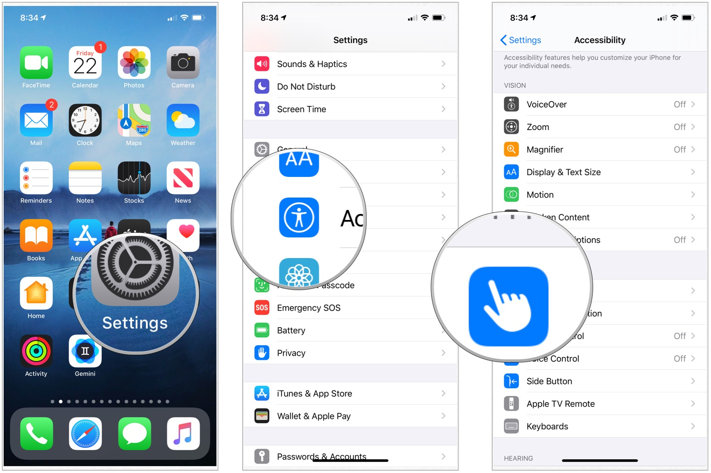
When you turn on AssistiveTouch, you see a button appear onscreen. You can drag the button to any edge of the screen, where it stays until you move it again.
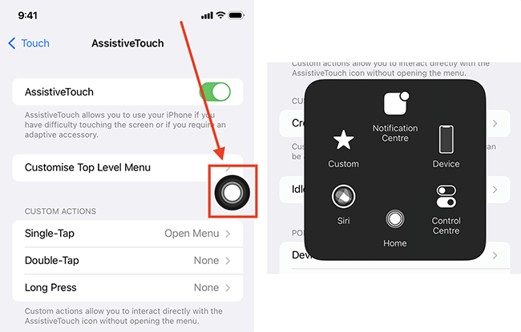
Go to Settings > Accessibility > Accessibility Shortcut, then select the features you want.

Triple-click the side button to switch it on and off

