Record/transcription: iOS 18.1 or later can record and transcribe phone calls:
To record and transcribe a phone call on an iPhone, you can use the following steps:
- Start recording: While on a call, tap the Record button in the top left corner of the screen.
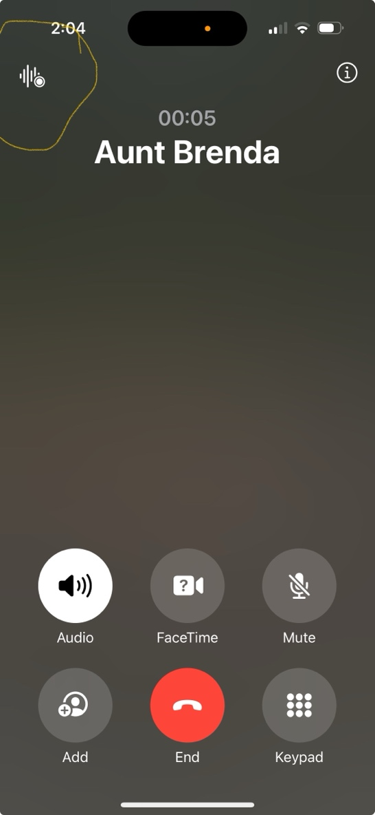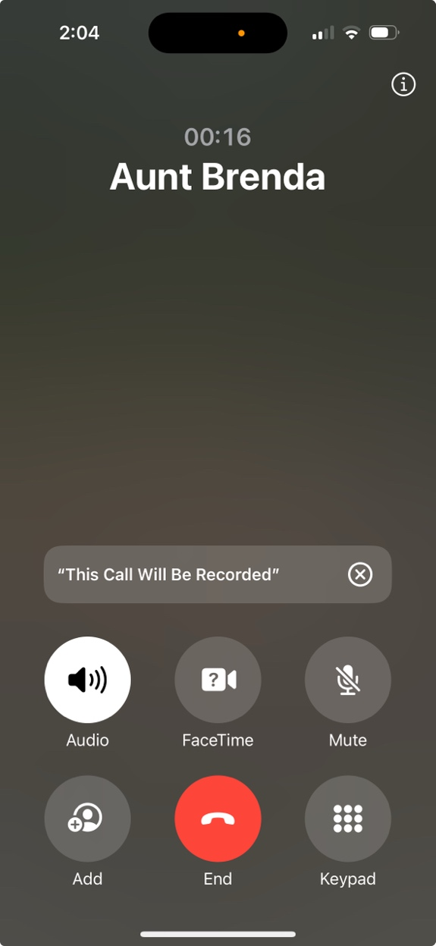

- Alert others: Siri will notify everyone on the call that it's being recorded.
- End recording: To stop recording, you can tap the Stop button or hang up.
- View recording and transcript: After ending the call, you'll receive a notification in the Notes app that the call recording has been created. You can tap the notification to open the recording and transcript in the Notes app.
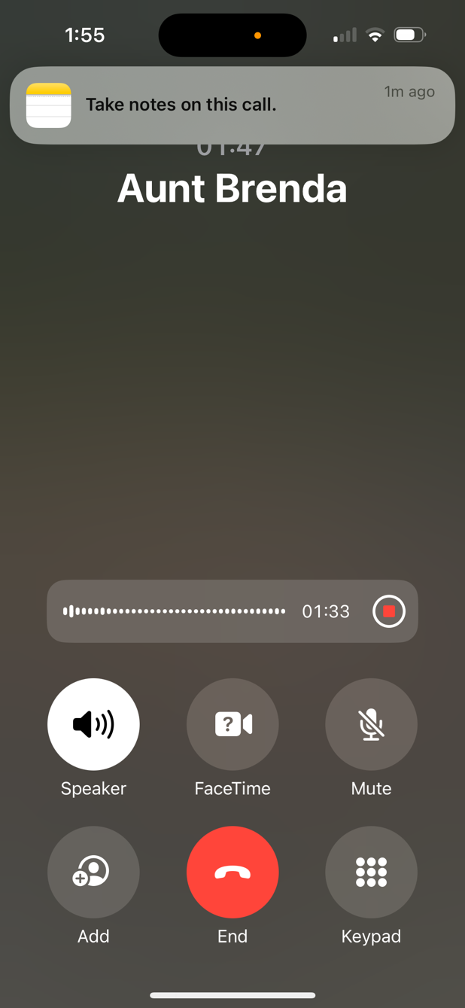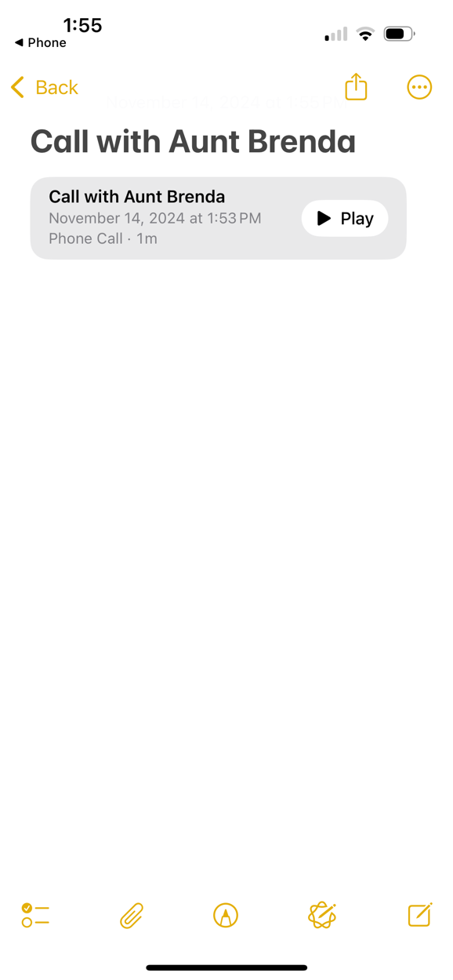
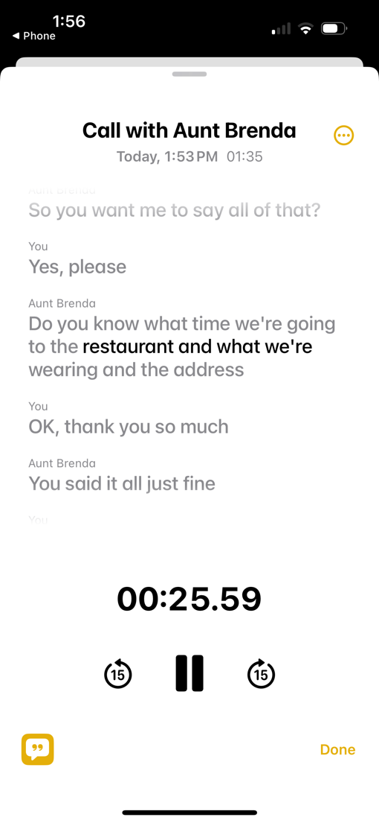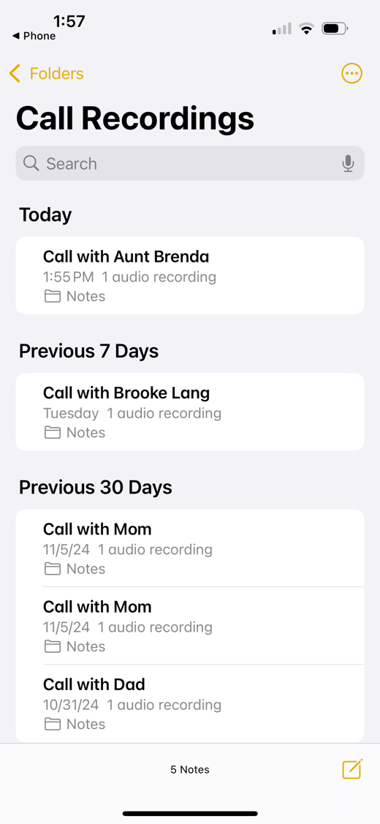

Here are some things to keep in mind:
- Call recording is not available in all regions and languages. You can check the iOS and iPadOS Feature Availability website to see if it's available in your area.
- You should make sure the other person on the call is willing to be recorded.
- You can also use Live Captions to automatically transcribe spoken audio on your iPhone.

