iPhone: Personal Voice
The "Personal Voice" feature on iPhone is part of Apple's suite of accessibility tools designed to help users create a personalized, synthetic voice that sounds similar to their own. Here's a general guide on how to use it:

1. Ensure You Have the Correct iOS Version: Make sure your iPhone is running an iOS version that includes Personal Voice. Check for software updates by going to Settings > General > Software Update.
2. Access the Accessibility Settings:
- Go to the "Settings" app on your iPhone.
- Tap on "Accessibility."
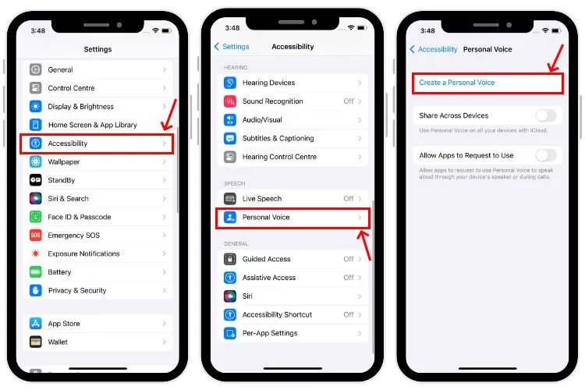

3. Set Up Personal Voice:
- Look for a section related to "Personal Voice" or "Speech" within Accessibility.
- Follow the on-screen instructions to create your Personal Voice. You might be prompted to record a set of phrases which will be used to generate your personalized synthetic voice.
- Ensure that you record the phrases in a quiet environment to improve the quality of your Personal Voice.

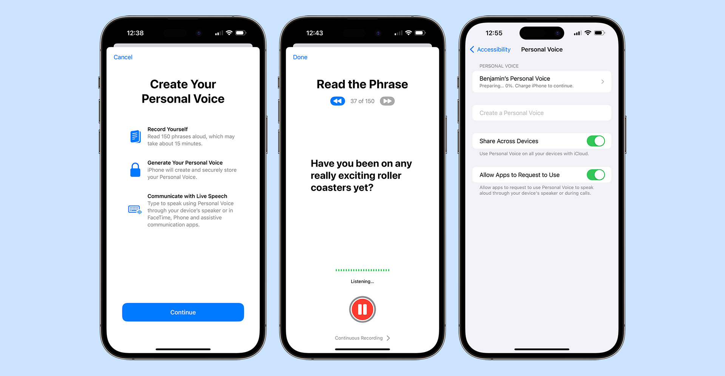

4. Using Your Personal Voice
- After setting up, your Personal Voice can be used with other iPhone features that support speech, such as communication apps or any app integrated with Apple's accessibility features.
- You might find specific settings in apps like Messages or FaceTime that allow you to choose and activate your Personal Voice during communication.

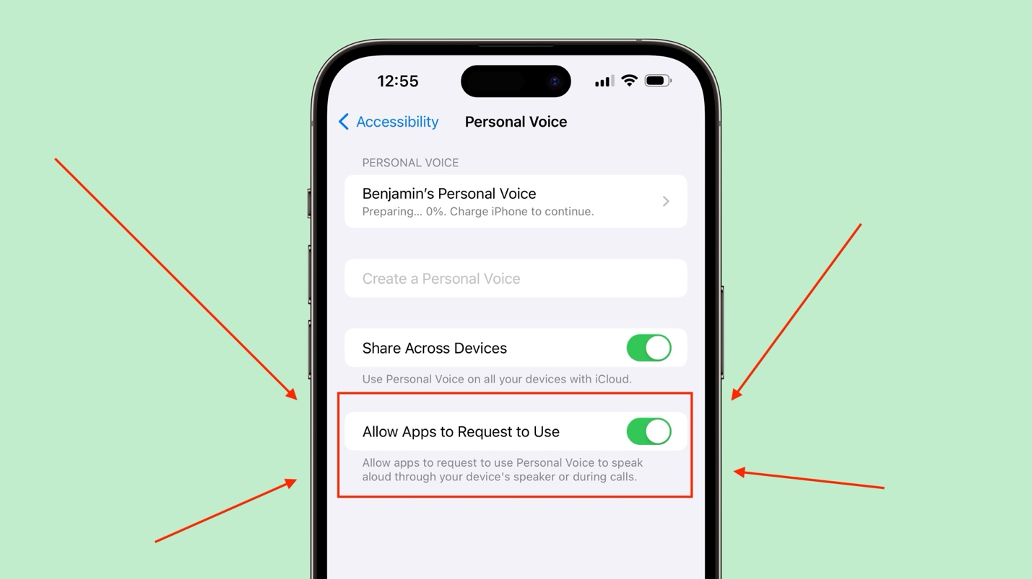

https://www.youtube.com/watch?v=N4AG5qRUWjo

https://www.youtube.com/watch?v=bDtuVp1ywTo

