iPhone: Bold, underline, italicize text in messages
**NOTE: If you are texting someone who DOES NOT have iOS update, their messages will NOT display the bold, underline, italicize

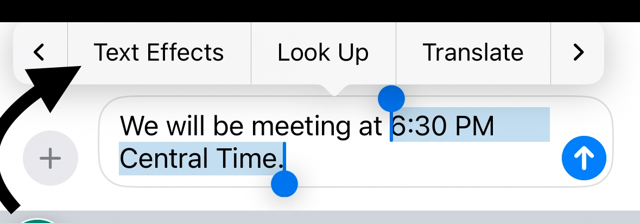
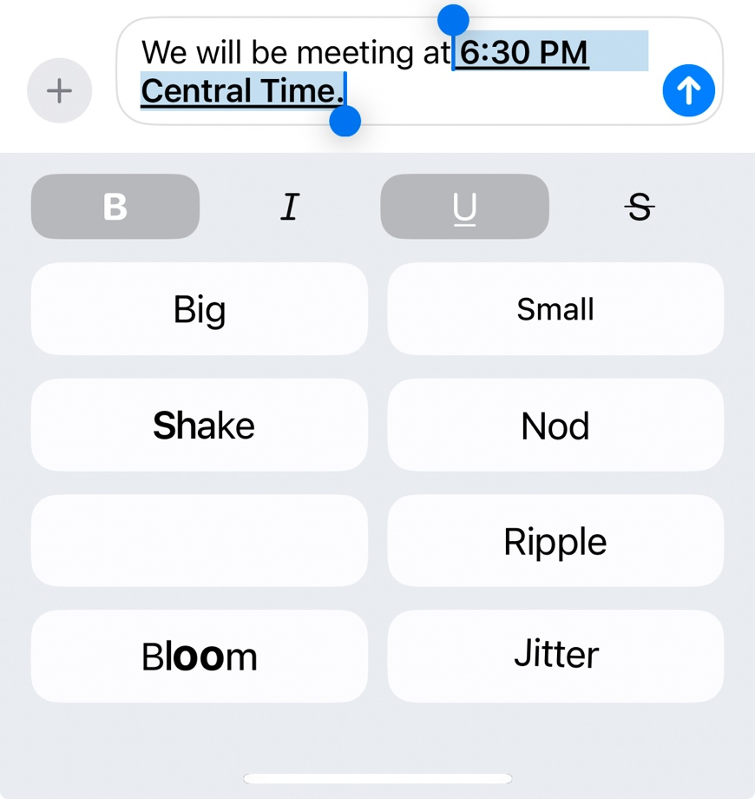

https://support.apple.com/guide/iphone/style-and-animate-messages-iphe5c5af4d4/ios#:~:text=Go%20to%20the%20Messages%20app,want%20to%20format%20or%20animate.&text=above%20the%20keyboard%2C%20then%20select,%2C%20bloom%2C%20or%20jitter).
iPhone: Compose a message to SEND LATER

Schedule a message
You can schedule a message up to 14 days into the future.
- Go to the Messages app  on your iPhone.
- Tap , then tap Send Later.
- Tap the time to open the scheduler, then choose when you want to send your message.
The border of the text field turns into a dashed line, and the time your message will be sent appears above the message.
- Enter a message, then tap .
The message appears with a dashed line until it’s time to send it, and it’s delivered even if all your devices are offline.

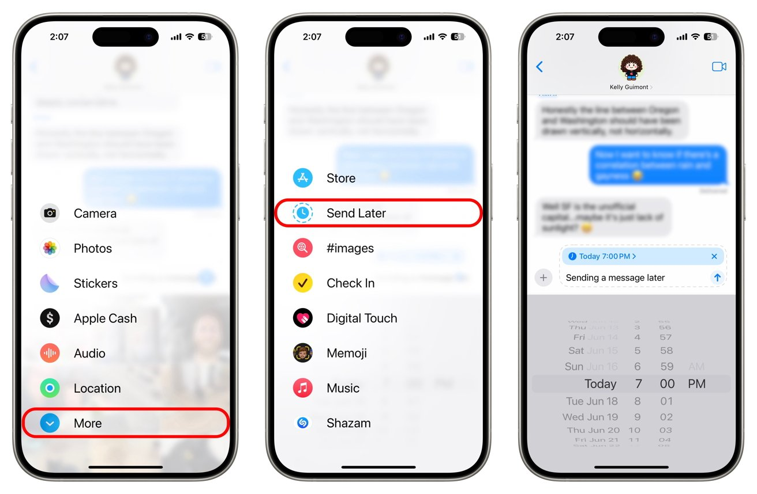
https://support.apple.com/guide/iphone/schedule-a-message-to-send-later-iph5ae9a7be6/ios

To SCHEDULE a text with
Google Messages (ANDROID)
- Start a new conversation or navigate to an existing conversation.
- Type out your message.
- Tap the ‘+’ icon to bring up the “schedule send” menu.
**Alternatively, you can press and hold the “send” button to bring up the “schedule send” menu (but be careful not to accidentally send the text before you’re ready).

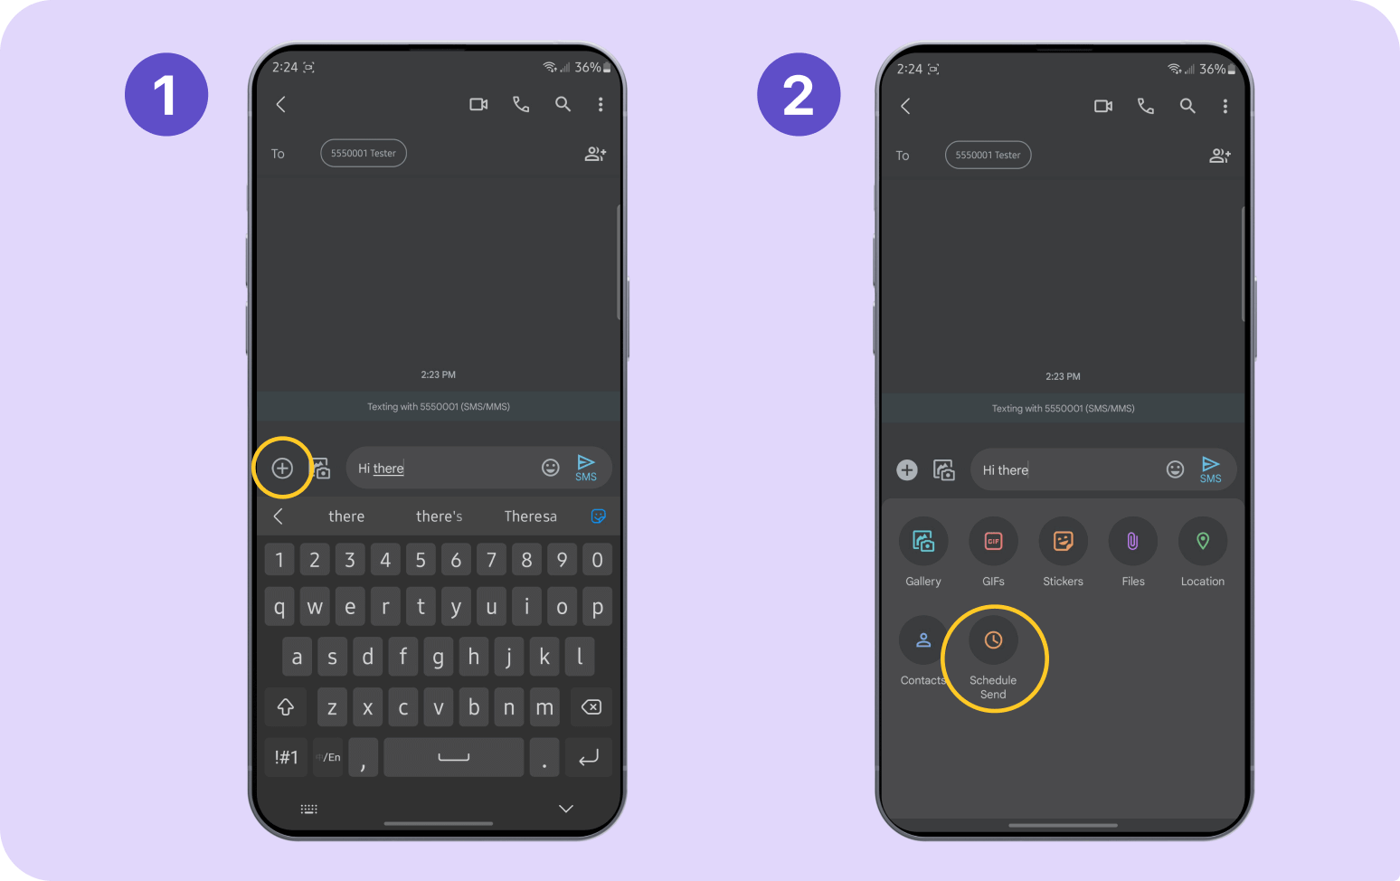
- Choose a preset delivery time or choose your own by tapping “pick date and time” and entering the timing information.
- Double-check your text, look for the banner stating the scheduled time, and then press the paper plane icon with a clock next to your message to schedule the text.
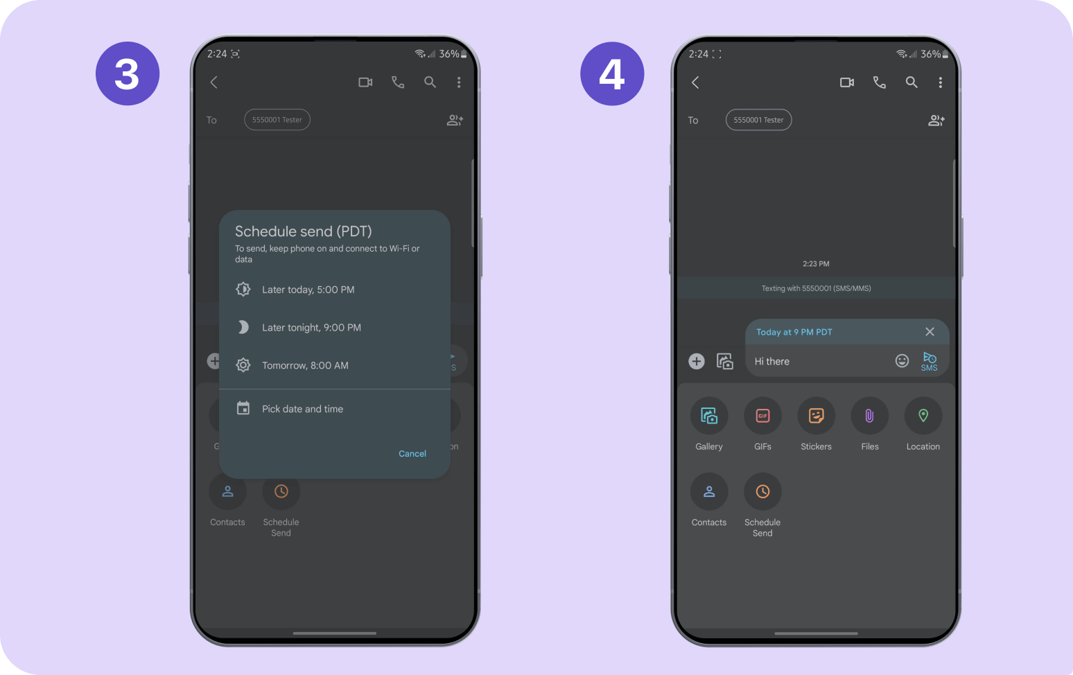
How to send scheduled texts using
Samsung Messages
- Create a new conversation or choose an existing one.
- Type your message.
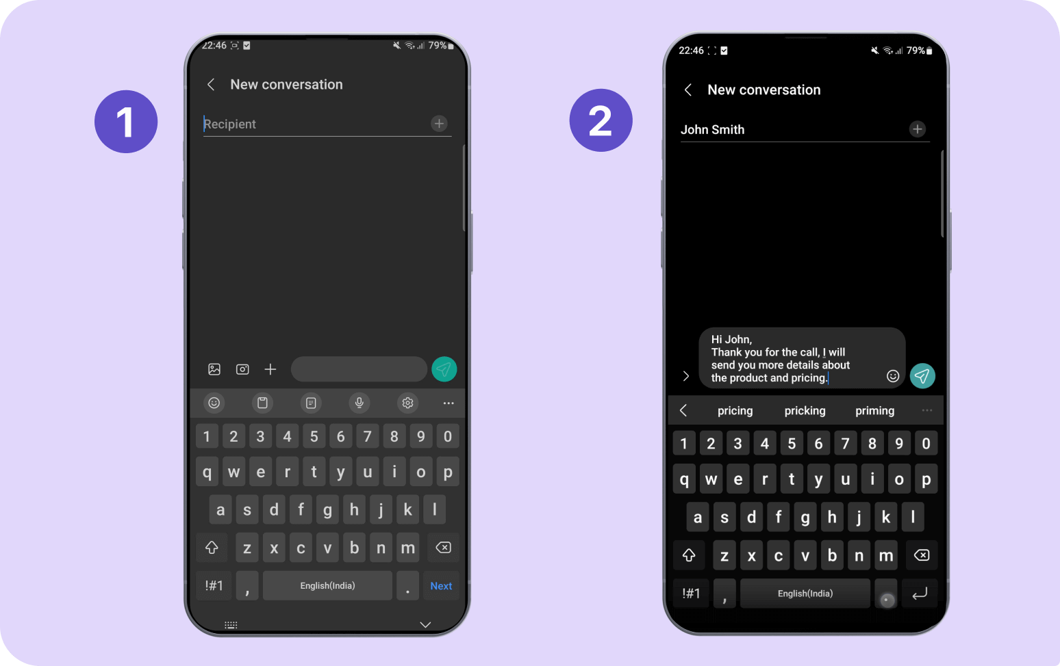
- Tap the chevron icon (>) on the left side of your message.
- Tap the ‘+’ icon to bring up the text menu options.
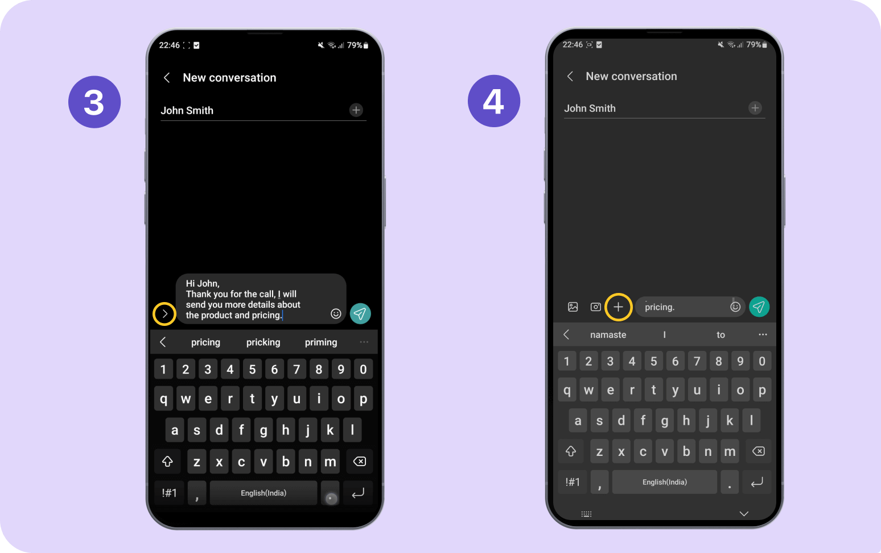
- Select “schedule message” to access the date and time options.
- Set your date and time within the provided range or choose “set schedule later” for more options, then press “done.”
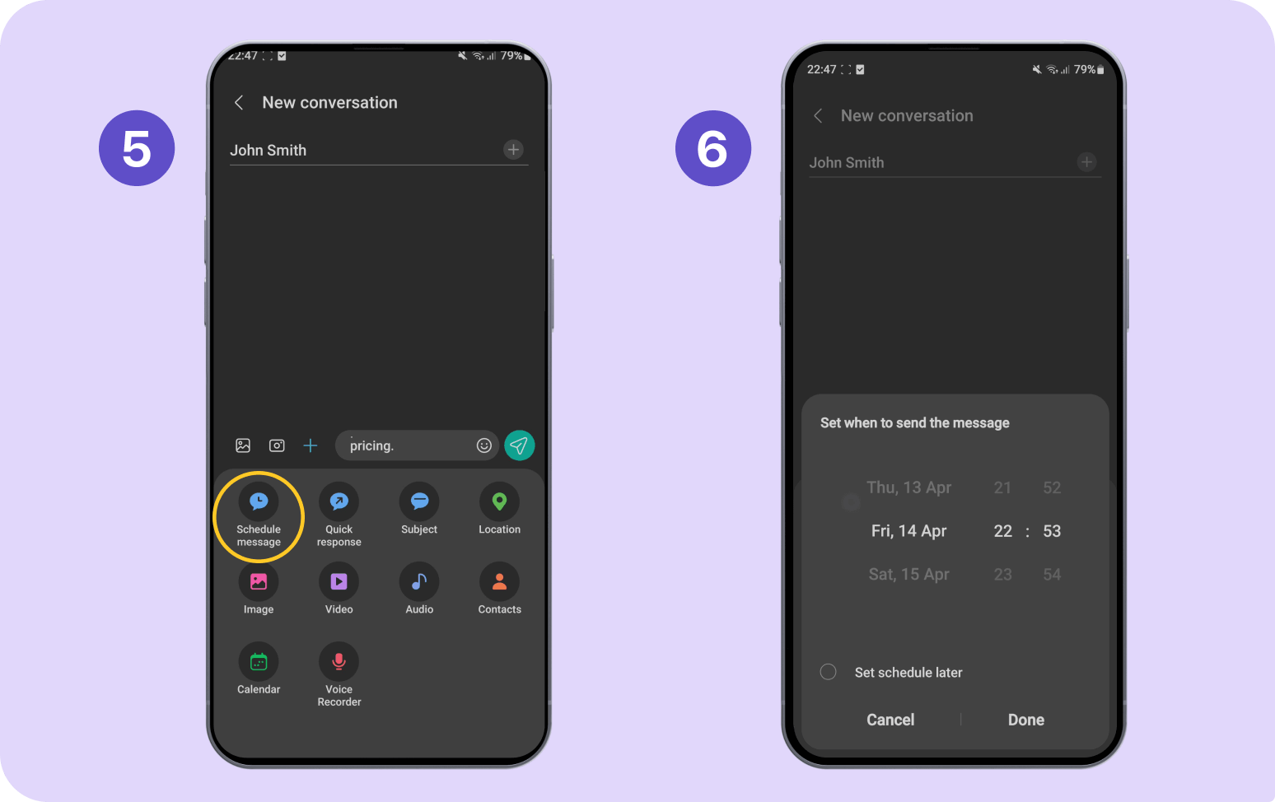
Review your message and ensure the time shown above your text is correct, then press the paper plane icon to the right of your message to schedule your text.
