Dr. Denise Mendez
Willow Grove, PA

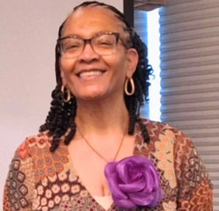
Dr. Denise Mendez “has aphasia, but aphasia does not have her!” She knows that she is more than any diagnosis, health challenge, or adverse event. Dr. Mendez has a passion for learning, teaching, and training others. She had nearly 30 years - teaching, supervising, curriculum & assessment development and administration, before experiencing a series of cranial hemorrhages that ended her career in public education.
Ever resilient-Denise has embraced another mission-increasing awareness and advocating for herself and for those impacted by stroke and aphasia. She also enjoys attending and presenting in conferences and looks for opportunities to teach about the lived experience of aphasia.
Denise stays busy with:
- More Than Aphasia, Inc. (a nonprofit) - President/CEO
- Creator and host of the “Still Something 2 Say” Podcast
- Mid-Atlantic Aphasia Conference - founding member, content programmer, and editor of the newsletter
- Philadelphia Aphasia Community at Temple (Univ.)-PACT
- ImPACT- advocacy arm of PACT
- Penn State Alumni Aphasia Support Group (virtual)- founding member/planner
- Salus/Drexel U. Speech Language Institute – therapy, support group, book club and poetry class
- Gray Matters Lab (San Fran State Univ.)- virtual support groups
- National Aphasia Association- virtual support groups and an Aphasia Ambassador
- Jackson State Univ. (Mississippi) -virtual support group
- Univ. South Carolina – virtual support
- Poems in Speech- Activity group (participant)
Contact Denise at:
www.morethanaphasia.org or morethanaphasia@gmail.com

